Project: Gmail Inbox Cleanup via API — Filtering & Categorization
Objective
Reduce inbox clutter by connecting directly to a personal Gmail account via API, extracting message data at scale, and applying filtering/categorization logic to identify and remove low-value messages (spam, unsubscribe-pattern emails, promotional content).
Approach
- Data extraction Connected to the Gmail account using the Gmail API to programmatically access inbox contents, rather than manually reviewing messages one by one.
1.Initial gmail box content
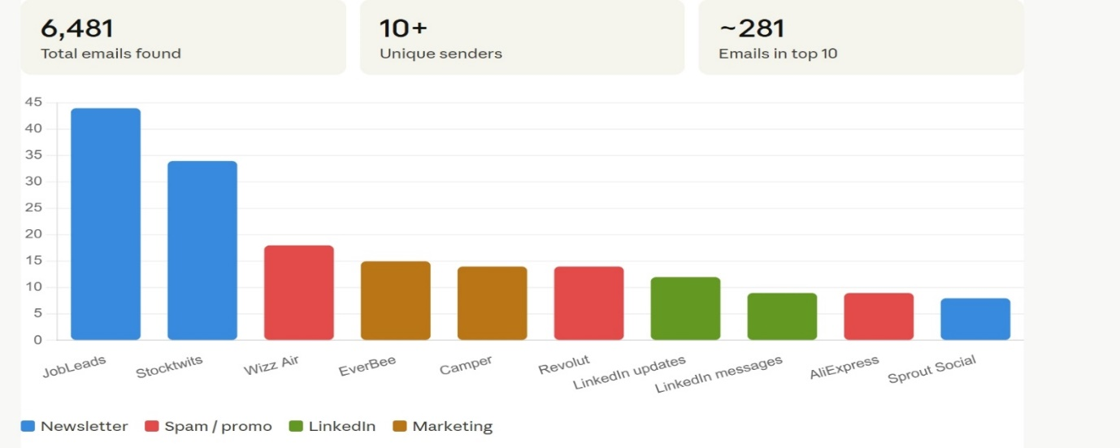
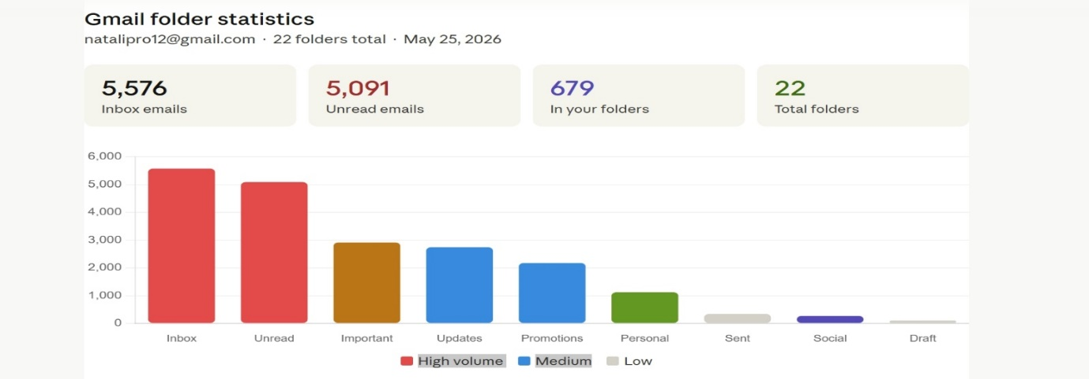

Project: Gmail Inbox Cleanup via API — Filtering & Categorization
Objective
Reduce inbox clutter by connecting directly to a personal Gmail account via API, extracting message data at scale, and applying filtering/categorization logic to identify and remove low-value messages (spam, unsubscribe-pattern emails, promotional content).
Approach
- Data extraction Connected to the Gmail account using the Gmail API to programmatically access inbox contents, rather than manually reviewing messages one by one.

2. Filtering logic Built rules to identify and flag low-value messages, including:
- Searching message bodies/subjects for patterns such as "unsubscribe" (a strong signal of promotional/marketing email)
- Identifying other common spam/marketing indicators (sender patterns, repeated senders, promotional keywords)
Statistic _ most common senders /spam 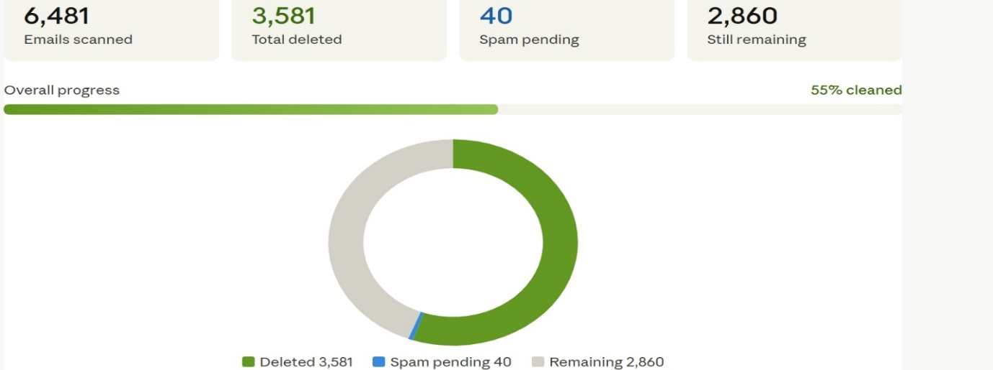
3. Categorization Grouped flagged messages into categories (e.g. promotional, spam, unsubscribe-pattern) to review before deletion, rather than deleting in one uncontrolled batch — ensuring important messages weren't accidentally caught by the filters.
4. Outcome Reduced total inbox volume from approximately 7,000 messages to 600 by systematically identifying and removing low-value email through the filtering/categorization logic above.
Skills Demonstrated
- API-based data extraction (Gmail API)
- Rule-based filtering and pattern matching at scale
- Categorization logic to reduce false positives before taking action
- Practical, self-directed problem solving using real-world data (not a synthetic dataset)
Relevance to Data Analyst Roles
This project mirrors core responsibilities in data-driven investigation roles: extracting data via API, applying pattern-detection logic to a large volume of records, and separating signal (genuine spam/promotional content) from noise (legitimate messages) before taking action — directly comparable to distinguishing genuine quality issues from false positives in a content or translation review context.

2. Filtering logic Built rules to identify and flag low-value messages, including:
- Searching message bodies/subjects for patterns such as "unsubscribe" (a strong signal of promotional/marketing email)
- Identifying other common spam/marketing indicators (sender patterns, repeated senders, promotional keywords)
3. Categorization Grouped flagged messages into categories (e.g. promotional, spam, unsubscribe-pattern) to review before deletion, rather than deleting in one uncontrolled batch — ensuring important messages weren't accidentally caught by the filters.
4. Outcome Reduced total inbox volume from approximately 7,000 messages to 600 by systematically identifying and removing low-value email through the filtering/categorization logic above.
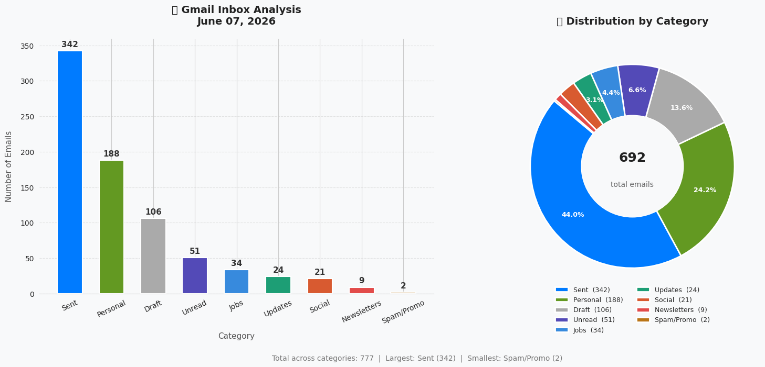

📊 STATS SUMMARY AFTER CLEANING
Sent 342 (44.0%) Personal 188 (24.2%)
Draft 106 (13.6%) Unread 51 (6.6%)
Jobs 34 (4.4%) Updates 24 (3.1%)
Social 21 (2.7%) Newsletters 9 (1.2% Spam/Promo 2 (0.3%)
───────────────────────────────────
TOTAL 777
Inbox total 692

Skills Demonstrated
- API-based data extraction (Gmail API)
- Rule-based filtering and pattern matching at scale
- Categorization logic to reduce false positives before taking action
- Practical, self-directed problem solving using real-world data (not a synthetic dataset)
Relevance to Data Analyst Roles
This project mirrors core responsibilities in data-driven investigation roles: extracting data via API, applying pattern-detection logic to a large volume of records, and separating signal (genuine spam/promotional content) from noise (legitimate messages) before taking action — directly comparable to distinguishing genuine quality issues from false positives in a content or translation review context.

